
LESSON NOTE | DETAILED EXPLANATORY NOTES
HEALTH AND MEDICAL BIOLOGY
DISEASE - DISRUPTION OF HOMEOSTASIS

GRADE 12 - BIOLOGY
■ ■ ■

What is Disease?
Disease is any failure of normal physiological function that leads to negative symptoms. Anything that stops a positive or negative feedback system from working correctly can lead to disease if the disruption becomes strong enough. While disease is often the result of infection or injury, most diseases involve the disruption of normal homeostasis - the body can no longer hold its internal conditions within their normal range.
Almost any homeostatic component can fail - through an inherited defect, an inborn error of metabolism, or an acquired disease. Some mechanisms have built-in redundancies so that life is not immediately threatened if one part fails, but a serious homeostatic failure can cause major, sometimes fatal, disease.
How Homeostasis Can Fail
- Inherited or genetic defects in a control mechanism (e.g. a missing hormone).
- Acquired disease, infection or injury that damages a sensor, control centre or effector.
- Ageing, as feedback loops gradually weaken and the internal environment becomes less stable.
- Decompensation, when the body's compensating mechanisms eventually wear out.
Disease - Disruption of Homeostasis
Key Learning Outcomes
By the end of this lesson, students should be able to:
- Explain how the disruption of homeostasis can lead to disease and, if severe, to fatal outcomes.
- Describe diabetes as a key example of failed homeostatic control.
- Describe normal blood-glucose regulation by insulin and glucagon.
- Distinguish type 1 and type 2 diabetes and their causes.
- Outline the treatment and complications of diabetes.
- Explain how homeostatic variables are measured to detect and monitor disease.
Homeostasis and Disease
In a healthy body, negative feedback detects any change from the set point and reverses it, returning the body to normal. In disease, this control breaks down: the change is no longer corrected, so the internal environment becomes unstable. The same feedback principle that keeps us well also explains what goes wrong when it fails.
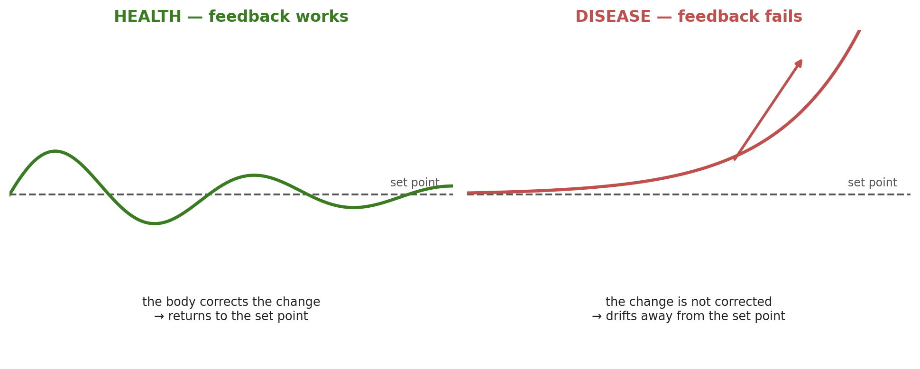
Figure 1: In health, feedback returns a parameter to its set point; in disease, the feedback fails and the parameter drifts away.
Terminologies and Concepts
Understanding the disruption of homeostasis requires familiarity with several key terms:
- Disease: a failure of normal physiological function that produces negative symptoms.
- Homeostatic imbalance / failure: the breakdown of a feedback mechanism that keeps a parameter stable.
- Compensation: the body covering for a failing mechanism by adjusting another.
- Decompensation: the point at which compensating mechanisms wear out and symptoms appear.
- Diabetes mellitus: a disorder of failed blood-glucose control, with chronically high blood glucose.
- Insulin resistance: when body cells stop responding properly to insulin.
- Hyperglycaemia / hypoglycaemia: blood glucose that is too high / too low.
Examples of Homeostatic Failure
Many serious conditions are, at heart, failures of homeostasis:
Condition | How homeostasis fails
Type 1 diabetes | Beta cells are destroyed, so insulin is not made and blood glucose rises uncontrollably.
Ageing | Feedback loops gradually weaken, making the internal environment less stable.
Chronic disease | Compensation hides a problem until the mechanisms wear out (decompensation).
Heart failure | Overwhelmed feedback leads to high pressure and an enlarged, weakened heart.
Kidney / liver failure | Loss of organs that regulate water, ions, pH and metabolism.
Diabetes: A Disease of Failed Homeostasis
Diabetes is a metabolic disorder caused by excess blood glucose, and it is the clearest example of a disease caused by failed homeostasis. Normally, homeostatic control should prevent this imbalance; but in some people the mechanisms do not work efficiently, or the glucose load is too great to manage, so medical intervention is needed to restore balance and prevent permanent organ damage.
Normal Blood-Glucose Regulation
The body holds blood glucose steady throughout the day. After a meal, glucose enters the blood from the small intestine and the pancreas (the sensor) releases insulin. Insulin binds to receptors on liver, muscle, fat and brain cells, making them take up glucose; the liver stores the excess as glycogen. This lowers blood glucose back to normal. Between meals, the pancreas releases glucagon, which makes the liver break glycogen back down into glucose (glycogenolysis) and release it - raising blood glucose. The two hormones work as opposing negative-feedback signals.
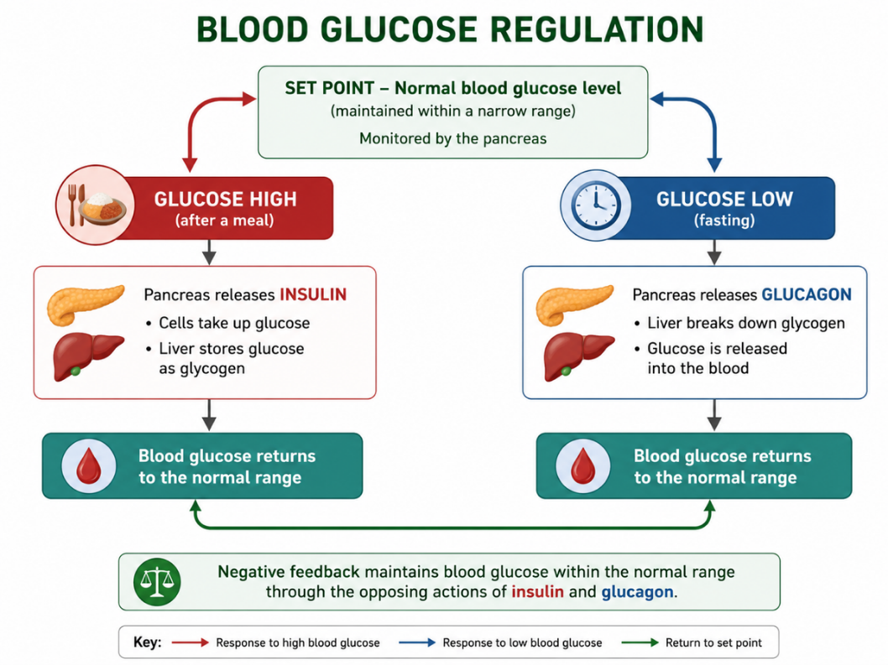
Figure 2: Normal glucose homeostasis — insulin lowers blood glucose, glucagon raises it.
Blood Glucose Through the Day
Over a day, blood glucose fluctuates only modestly around its set point. Each meal triggers a rise that is counteracted by insulin; between meals the level falls and is raised again by glucagon. This constant adjustment keeps glucose within a narrow, healthy range - and it is exactly this balance that diabetes destroys.
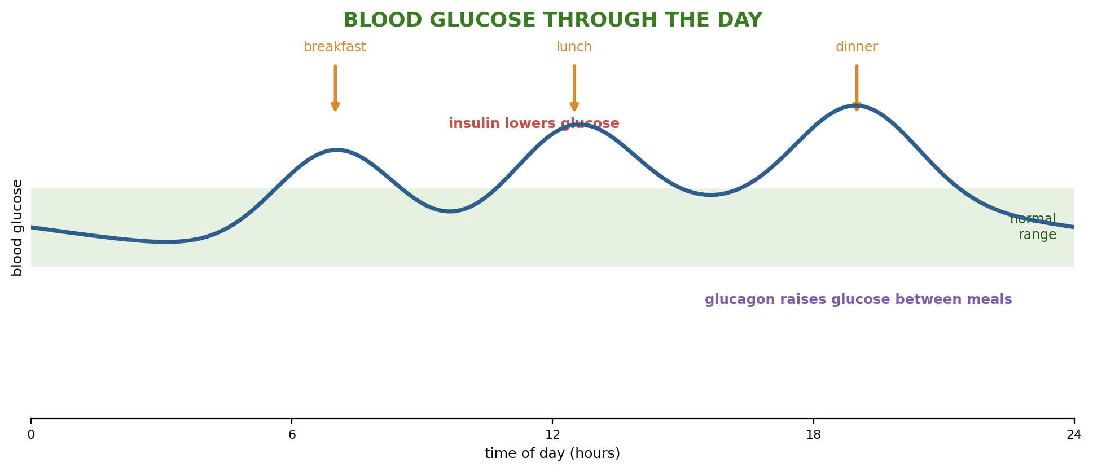
Figure 3: Blood glucose rises after meals (lowered by insulin) and falls between them (raised by glucagon).
Types and Causes of Diabetes
Diabetes is a disease caused by a broken feedback loop involving insulin. In type 1 diabetes, the insulin-producing beta cells are destroyed by the body's own immune system (an auto-immune reaction), so little or no insulin is made. In type 2 diabetes, the cells gradually stop responding to insulin (insulin resistance). In both, glucagon keeps raising glucose but the missing or ineffective insulin means blood glucose cannot return to normal - it stays high (hyperglycaemia).
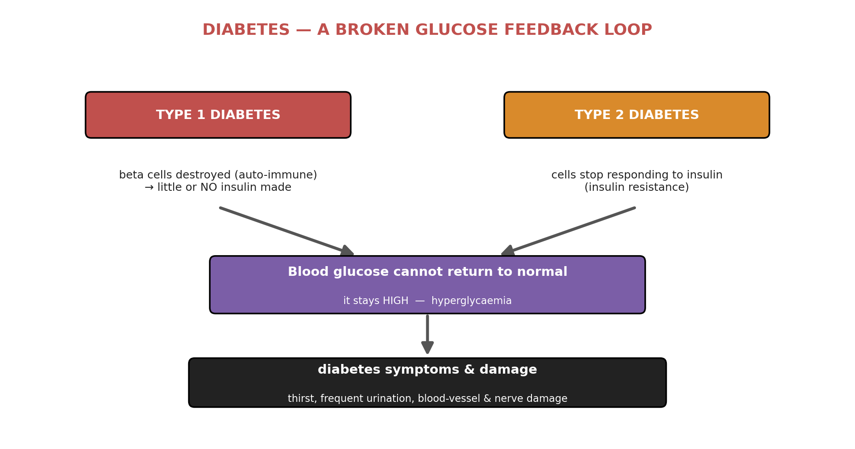
Figure 4: Diabetes - in both type 1 and type 2 the glucose feedback loop is broken, so blood glucose stays high.

Feature | Type 1 diabetes | Type 2 diabetes
Cause | Auto-immune destruction of beta cells | Cells develop insulin resistance
Insulin | Little or none produced | Produced, but cells do not respond
Typical onset | Often in childhood / youth | Often later; linked to lifestyle
Main treatment | Insulin injections | Diet, exercise and medication
Treatment and Complications
Diabetes is normally treated by insulin injections, which replace the missing negative feedback of natural insulin, together with diet and lifestyle management. If diabetes is left untreated or poorly controlled, the prolonged high glucose causes serious complications: weakened blood vessels, frequent urination and thirst, peripheral neuropathy (loss of feeling in the hands and feet), poor circulation in the limbs, and blurred vision or blindness. Careful monitoring and treatment keep these in check.
Worked Example - Tracing the Failure in Type 1 Diabetes
Situation: a person with type 1 diabetes eats a meal, and blood glucose rises.
- Stimulus: blood glucose rises after the meal - as normal.
- Sensor: the pancreas detects the rise - as normal.
- The break: the beta cells are destroyed, so no insulin is released.
- No response: the liver and other cells are not signalled to take up glucose.
- Result: blood glucose stays high (hyperglycaemia) instead of returning to the set point.
The feedback loop is broken at the response step. Treatment works by supplying insulin from outside, restoring the missing part of the loop.
Why This Matters
- Understanding disease - most illnesses are, at root, a breakdown of homeostatic control.
- Diagnosis - measuring parameters such as blood glucose reveals when homeostasis has failed.
- Treatment - medicine often works by restoring the missing feedback (e.g. insulin for diabetes).
- Prevention - lifestyle choices help keep feedback systems working and reduce disease risk.
PNG Context Example
Diabetes is a growing health concern in Papua New Guinea, especially type 2 diabetes linked to changing diets and lifestyles. Health workers use a glucometer to measure blood glucose and detect this homeostatic failure, and manage patients through insulin, diet and exercise. Understanding the disease helps communities reduce risk through healthy eating and physical activity, linking school biology directly to public health.
References & Related Documents
Source Documents
- STEM Biology Student Resource Book - Grade 12, Term 1. Module 12.1 Health and Medical Biology, Topic 2: Disease - Disruption of Homeostasis (What is Disease?; Diabetes; Normal Blood-Sugar Regulation; Causes of Disruption). Department of Education, PNG (2021).
- STEM Biology Syllabus - Grade 12, Term 1. Topic 2: Disease - Disruption of Homeostasis; Performance Indicators 12.1.2a–12.1.2c.
- Biology Standards-Based Syllabus, Grades 11 & 12 (PNG SBC 2020) - Strand 2: Life; Grade 12 evidence outcome: “Investigate how homeostatic balance occurs in cells and organisms.”
Further Reading & References
- OpenStax Anatomy & Physiology - Homeostasis; The Endocrine Pancreas. https://openstax.org/books/anatomy-and-physiology
- Khan Academy - Homeostasis; Diabetes. https://www.khanacademy.org/science/biology

